Attempt any 5 questions.

1. What do you mean by abstract data type? Write an algorithm to convert infix to prefix expression. Convert (A+B\*D) infix into prefix expression. [2+4+4]
2. Define stack with it’s operation. Write an algorithm to insert the node in between the any two nodes in doubly linked list with necessary diagram. [4+6]
3. Define directed and undirected recursion. Write an algorithm for TOH. Show the steps involving to solve the TOH for n=3 using necessary diagram. [4+6]

Or, Define directed and undirected recursion. Write an algorithm to add two polynomials with an example. [4+6]

1. Define pre order and in order in binary tress with an examples. Create AVL trees for months of year. [4+6]
2. Define minimum spanning trees with an example. Write an algorithm for bubble sorting with an examples.[4+6]
3. Mention some real life applications of hashing. Describe the collision resolution techniques. [4+6]
4. Apply Kruskal’s algorithm on the graph given in Fig. [10]  
   Initially, we have F = {{A}, {B}, {C}, {D}, {E}, {F}}

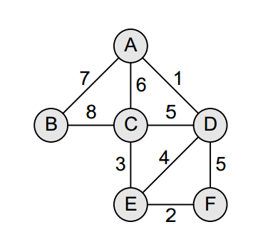

1. Consider the unweighted graph G given in Fig. and apply Warshall’s algorithm. [10]

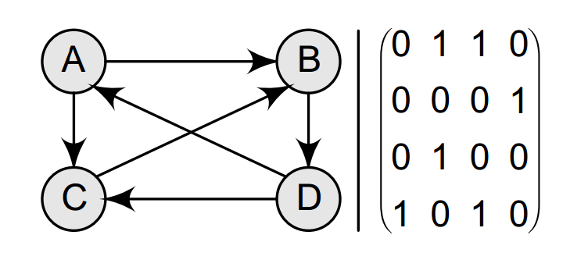

1. What do you mean by Abstract Data Tsype? Write an algorithm to convert infix to postfix expression. Convert (a+b-d\*(e+f)^g/h) infix into postfix expression. [2+3+3]
2. Define queue with it’s operation Write an algorithm to insert the node at the end of the nodes in doubly linked list with necessary diagram. [2+6]
3. Define tail and non-tail recursion with example. Write an algorithm for TOH. Show the steps involving to solve the TOH for n=4 using necessary diagram.[2+6]
4. Define preorder and post order in binary tress with an examples. Create AVL trees for months of year. [2+6]
5. Define weighted and un-weighted graph. Write an algorithm for radix sorting with an examples.[2+6]
6. Define hash function. Describe the collision resolution techniques. [2+6]
7. Apply Kruskal’s algorithm on the graph given in Fig. [8]  
   Initially, we have F = {{A}, {B}, {C}, {D}, {E}, {F}}



1. Consider the unweighted graph G given in Fig. and apply Warshall’s algorithm.[8]

